Screenshots or program listings must be copied into appropriate cells in the following table.
Save this evidence document as evidence_ followed by your centre number_ candidate number. For example: evidence_ zz999_9999 and insert your name, centre number and candidate number into the header above.
Examiners must be able to read the contents including any screenshots without the use of a magnifying glass. Answers that are not readable or missing will not be awarded any marks.
Save this evidence document at regular intervals, for example, every 10 minutes.
Question 1
Part 1(a)
def Unknown(X, Y):
if X < Y:
print(X + Y)
return (Unknown(X + 1, Y) * 2)
else:
if X == Y:
return 1
else:
print(X + Y)
return (Unknown(X - 1, Y) // 2)

Part 1(b)(i)
Unknown(10, 15)
Unknown(10, 10)
Unknown(15, 10)

Part 1(b)(ii)
parameters1 = [10, 15]
print(f"Parameters: X: {parameters1[0]} and Y: {parameters1[1]}")
result1 = Unknown(parameters1[0], parameters1[1])
print(result1)

parameters2 = [10, 10]
print(f"Parameters: X: {parameters2[0]} and Y: {parameters2[1]}")
result2 = Unknown(parameters2[0], parameters2[1])
print(result2)

parameters3 = [15, 10]
print(f"Parameters: X: {parameters3[0]} and Y: {parameters3[1]}")
result3 = Unknown(parameters3[0], parameters3[1])
print(result3)

Part 1(c)
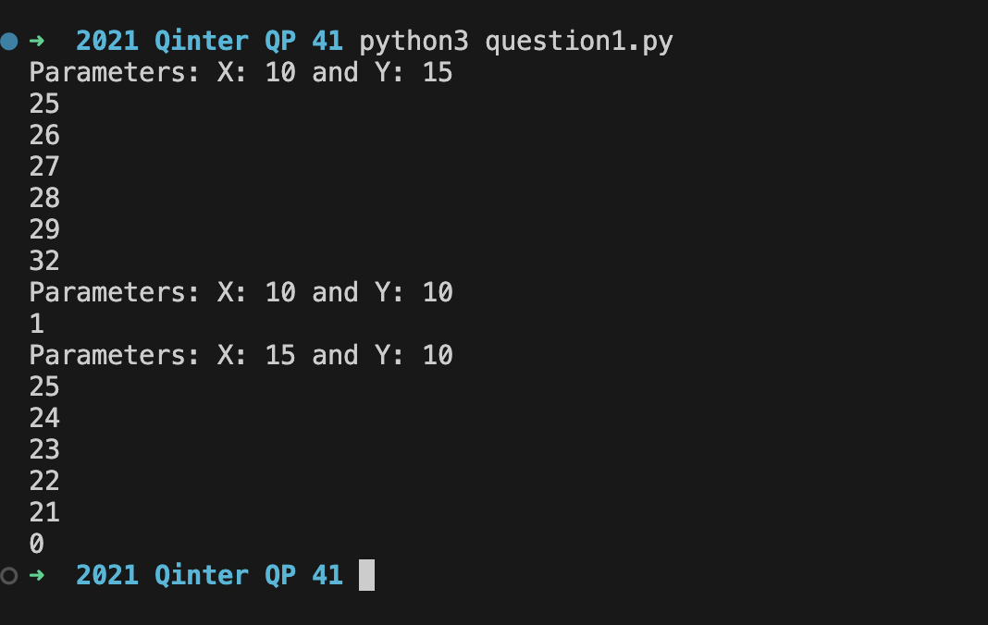

Part 1(d)(i)
def IterativeUnknown(X, Y):
for i in range(X, Y+1):
if X < Y:
print(X + Y)
else:
if X == Y:
return 1
else:
print(X + Y)

Part 1(d)(ii)
{Copy and paste the screenshot(s) for question 1(d)(ii) here}

Question 2
Part 2(a)
{Copy and paste the program code for question 2(a) here}

Part 2(b)
{Copy and paste the program code for question 2(b) here}

Part 2(c)
{Copy and paste the program code for question 2(c) here}

Part 2(d)
{Copy and paste the program code for question 2(d) here}

Part 2(e)
{Copy and paste the program code for question 2(e) here}

Part 2(f)
{Copy and paste the program code for question 2(f) here}

Part 2(g)
{Copy and paste the program code for question 2(g) here}

Part 2(h)
{Copy and paste the screenshot(s) for question 2(h) here}

Question 3
Part 3(a)
{Copy and paste the program code for question 3(a) here}

Part 3(b)
{Copy and paste the program code for question 3(b) here}

Part 3(c)
{Copy and paste the program code for question 3(c) here}

Part 3(d)(i)
{Copy and paste the program code for question 3(d)(i) here}

Part 3(d)(ii)
{Copy and paste the screenshot for question 3(d)(ii) here}

Part 3(e)(i)
{Copy and paste the program code for question 3(e)(i) here}

Part 3(e)(ii)
{Copy and paste the screenshot for question 3(e)(ii) here}

